CW: sexual content, racism, doxxing, sexism, etc.

first of all, you may ask “who the fuck is GuestSneezePlayz?” he’s a manipulative asshole.
he tries his best to get all the attention on discord, and he somehow gets it because he’s a underage person 100%. he says he’s 15, but that can’t be true, because he’s way too autistic and he does NOT act like a 15 year old. make sure to call his mod Half-Life 2 Recharged - the sun is leaking: redux.
edit: now he says he’s 14 and that he lied back then

he WAS claiming that he had a source engine license, but that’s not true because the ‘license’ he sent as proof was made by AI.
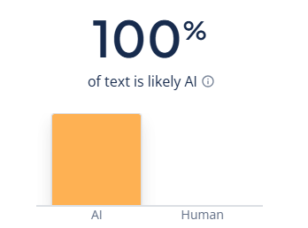

a bit of history, he had a project called ‘FalconCraft’, which was a web minecraft type of thing, which was raided after. after that he made a linux distro called ‘GuestSneezeOS’.
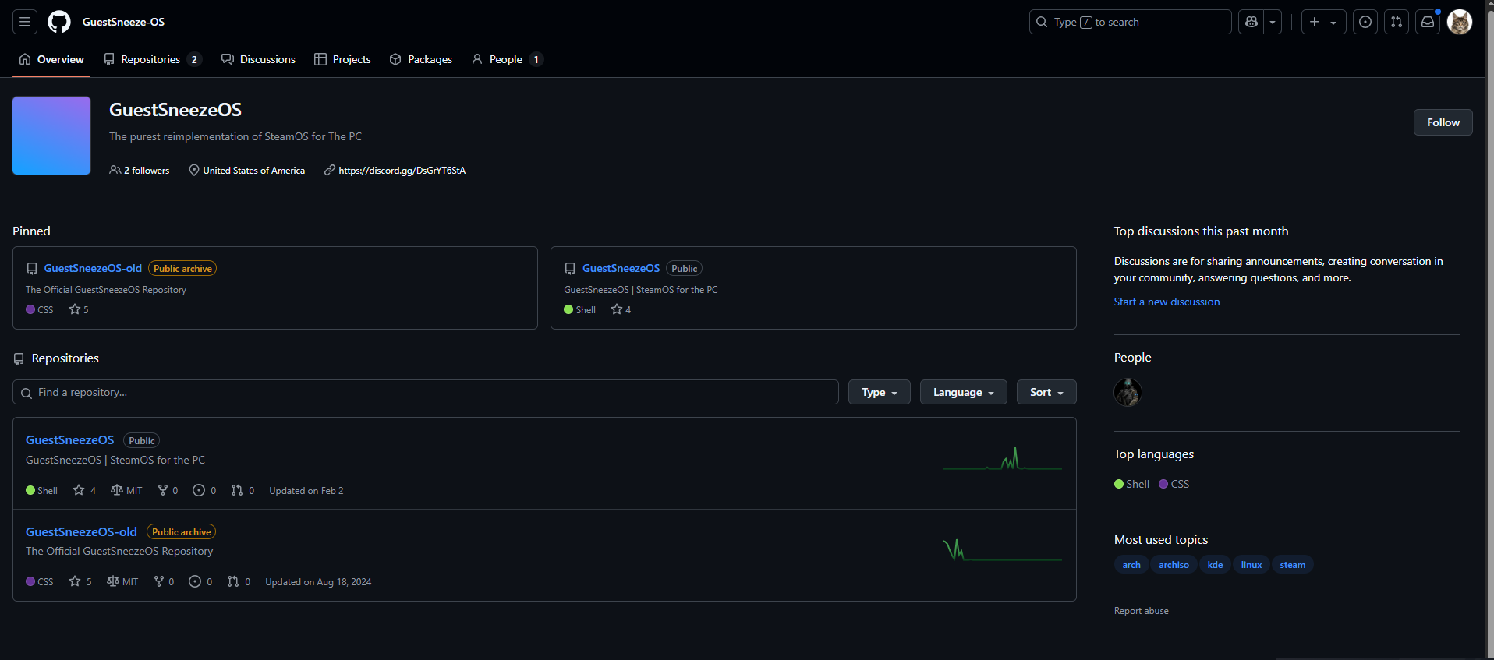

he also has a project which is a fork of CS:GO leaked source code, which he uses to add ‘emscripten’ to then brag about it (even tho it doesn’t work because he can’t port anything else other than tiers, mathlib and other small stuff). https://github.com/LambdaComplexSource/LambdaComplexSource

if you want, you can call him “thlple alt”. i’m pretty sure that’ll offend him, but it’s just an inside joke of mine. and please note that most of the screenshots are just his main account but renamed, or either his alts.

here’s his account at the current date of editing, may 24th 2025:
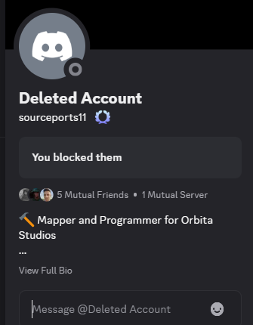

i met him for the first time when i saw the mod called GuestSandbox in ModDB, he seemed like a chill guy but when i tried to contact him i knew something was off. later i realized he was stealing stuff, and when i confronted him about it, he said this:
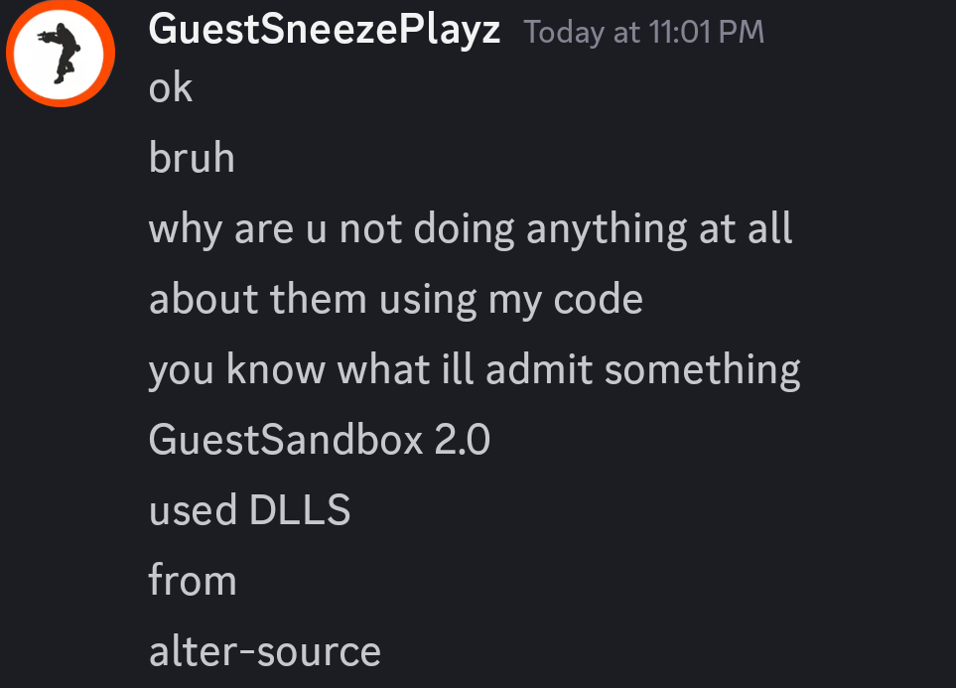
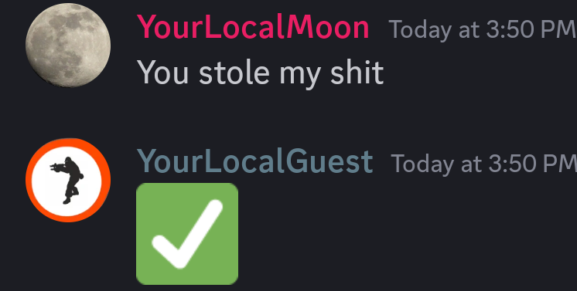

alter-source is a sandbox mod of mine, which is probably better than most of the mods on ModDB (except for garry’s mod, it's perfect)
GuestSandbox is a typical, ordinary and bland mod, with nothing but a crappy physics manipulator, stolen assets and stolen spawnmenu (it was originally made for JBMod as an addon)

he also leaked 2 mods: HL2:CE, and my friend’s mod called Simple Mod. the Simple Mod one is shown in the screenshot below.
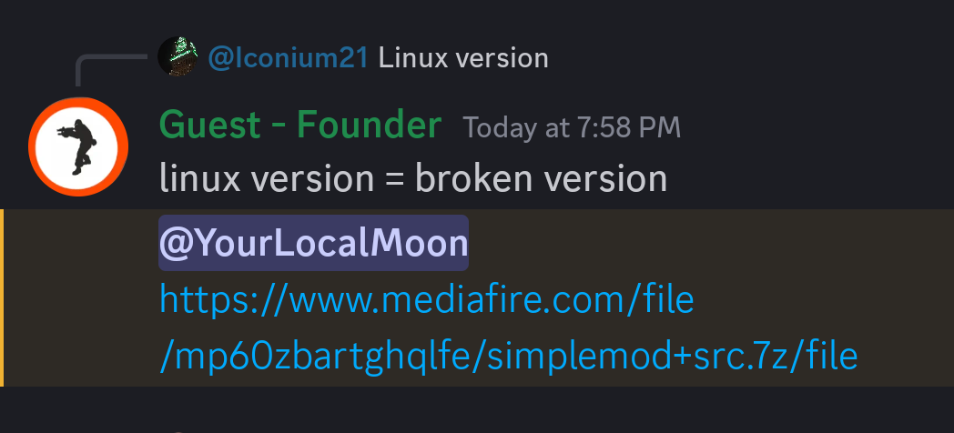
he also leaked a mod of my other friend called gopen

he also likes to copy people, and it’s shown in the screenshot below.
probably because he’s trying to be better than everyone, since that’s what he does also.
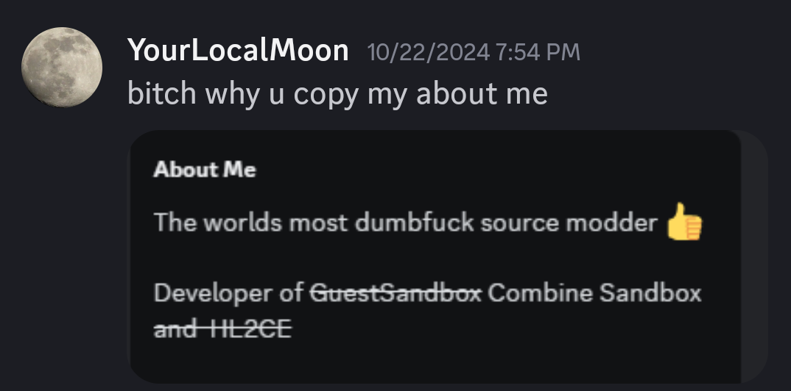

he keeps overrating his stuff, calling it better than others, and other shit.

one time it even lead to a ip (fake one, if you will try to ddos, nothing will happen to me) leak. little did they know it wasn’t me, and they got reported, but discord didn’t do shit. after GuestSandbox got deleted, he made another mod called GSPMod, which is basically ban evasion. later on, he renamed it to Combine Sandbox.
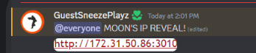

harassing
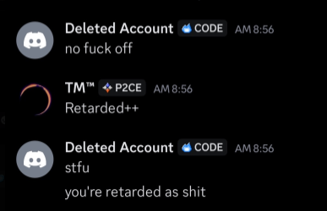
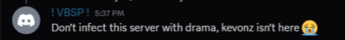
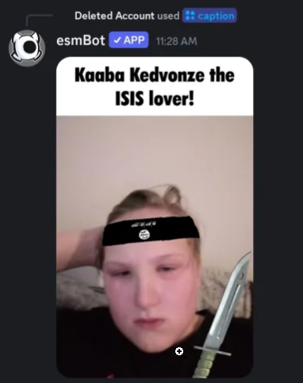
raiding
he did some questionable stuff
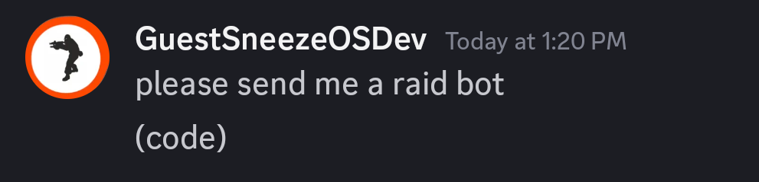
and he joined a raid group
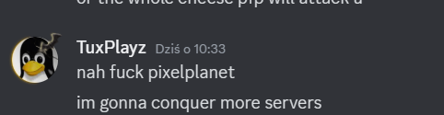
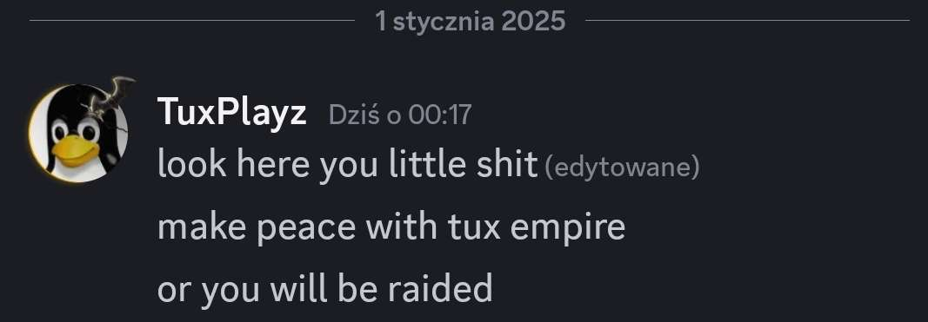
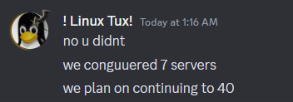
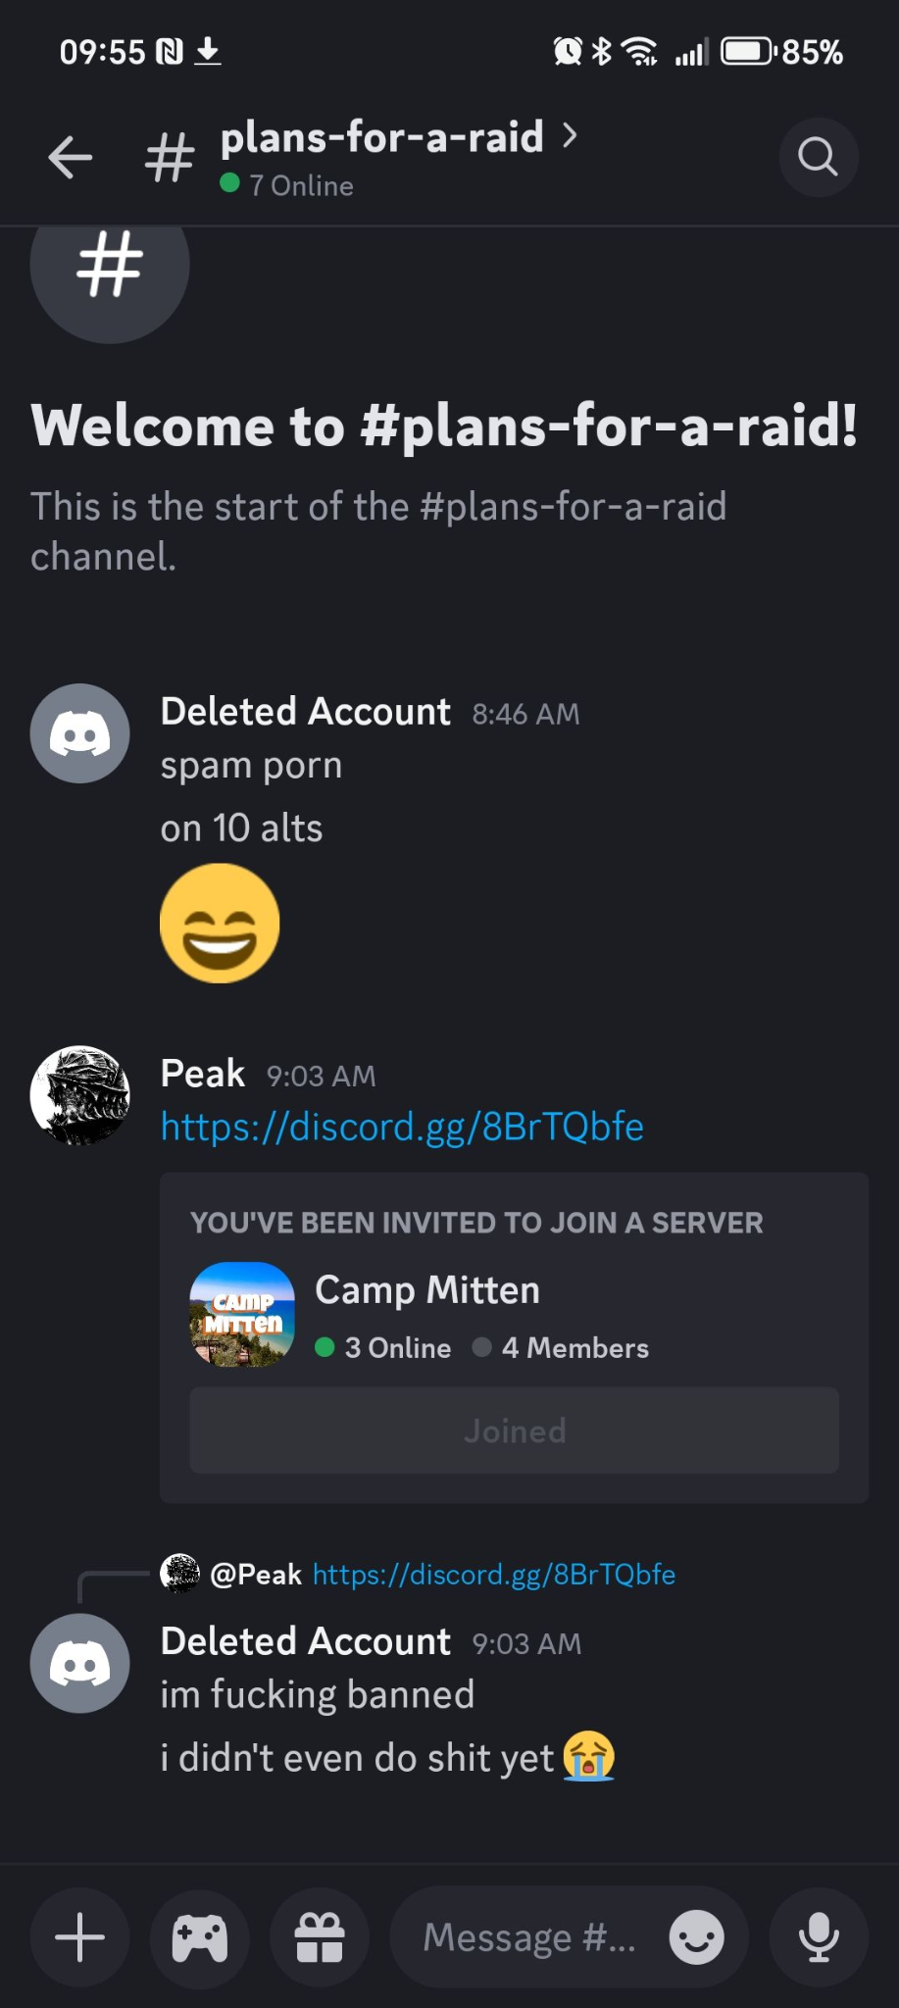

he also did raid a server once
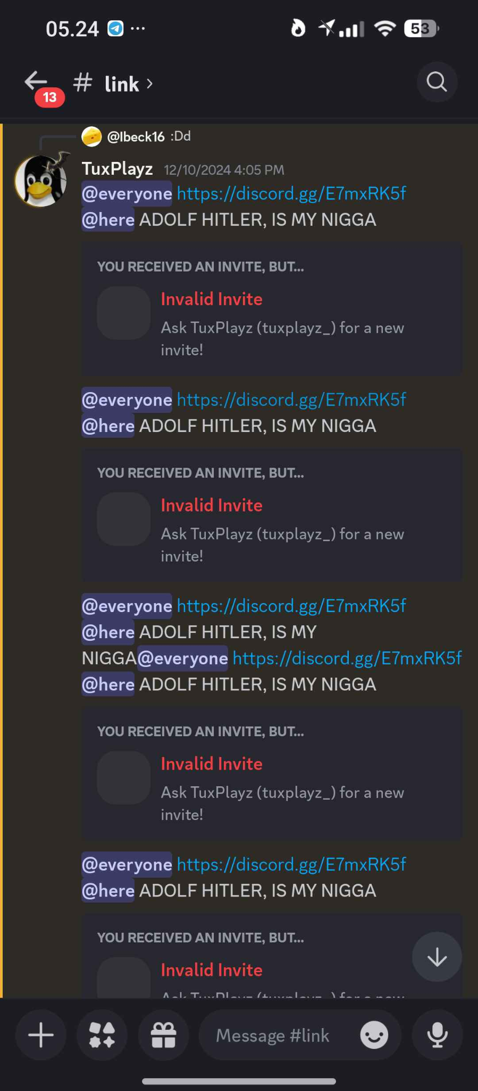

racism
i’m not even going to comment this one, just look:
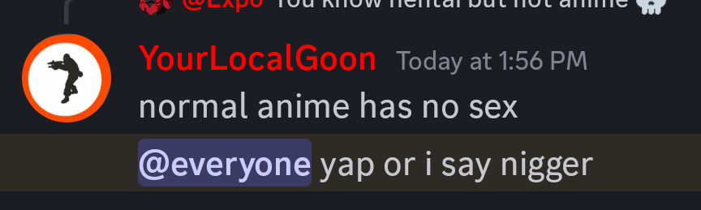
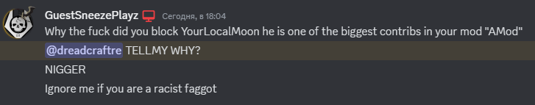
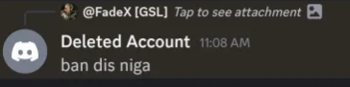
a bit of humor:
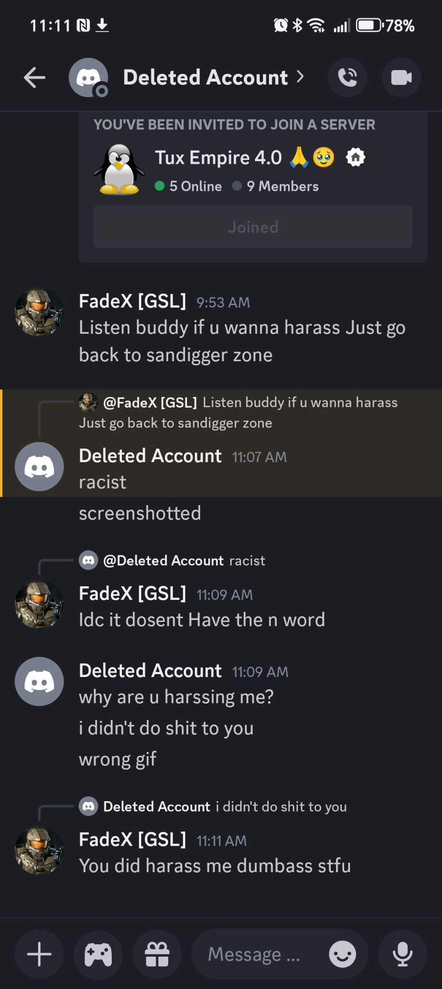
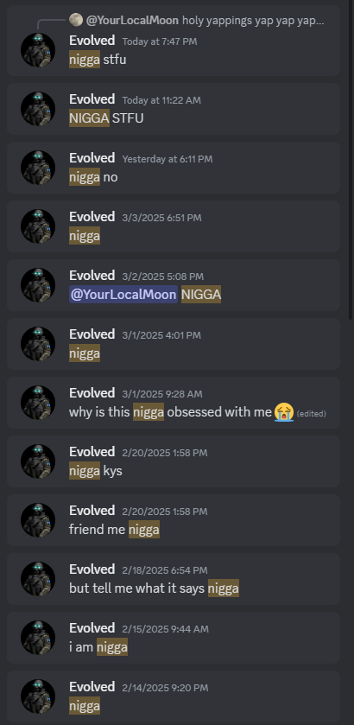
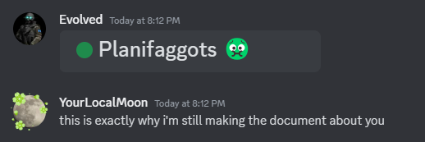
he literally said the hard r. no he’s not black.

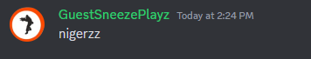
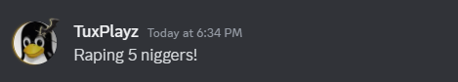
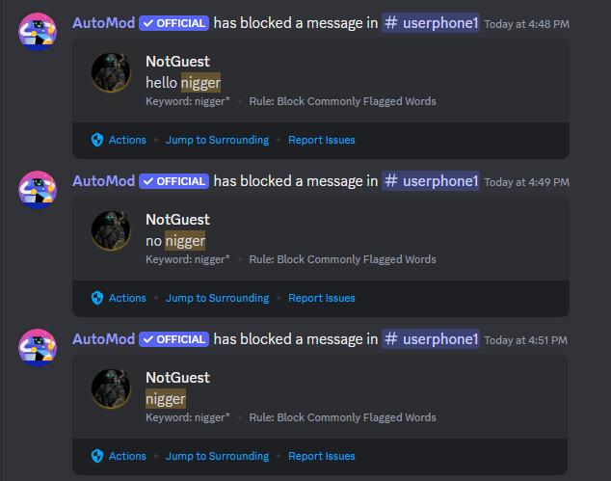
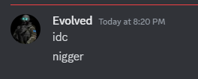
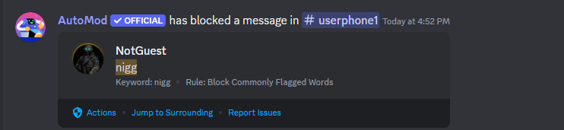
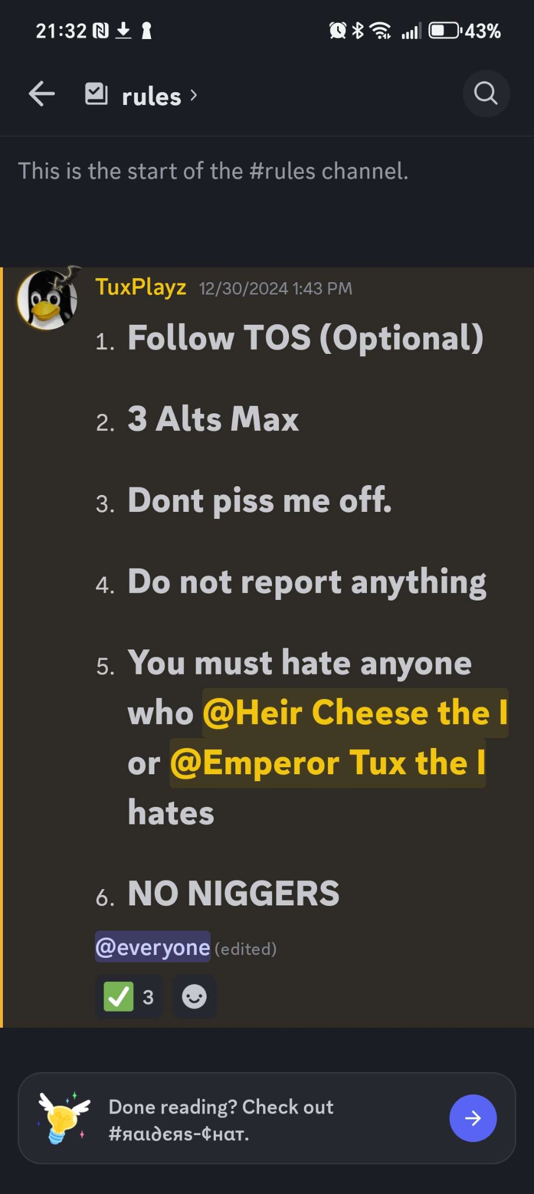
this too

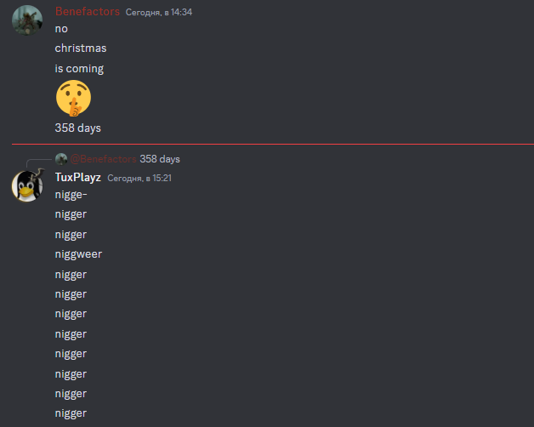
this
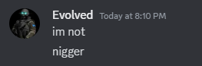
and this

and he proved that he’s white so it’s true
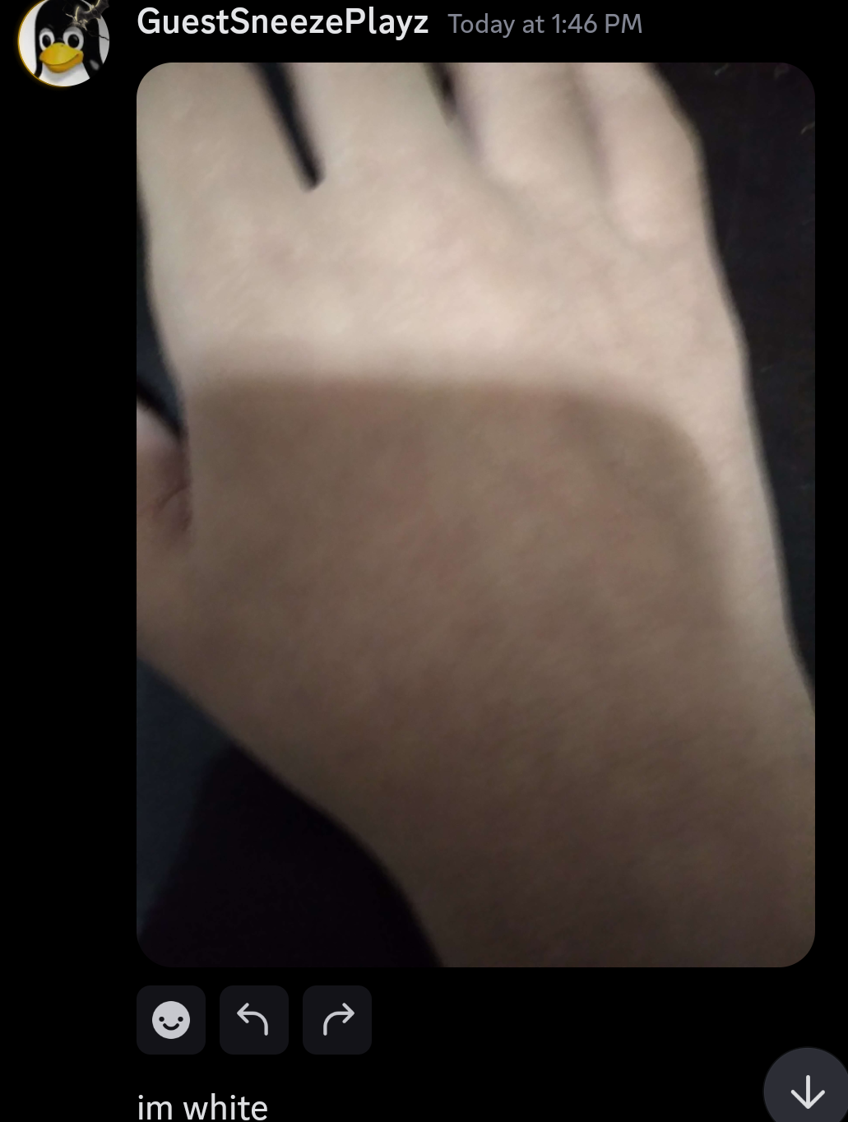

what about sexism? here’s what he said once in a dev-chat in discord.
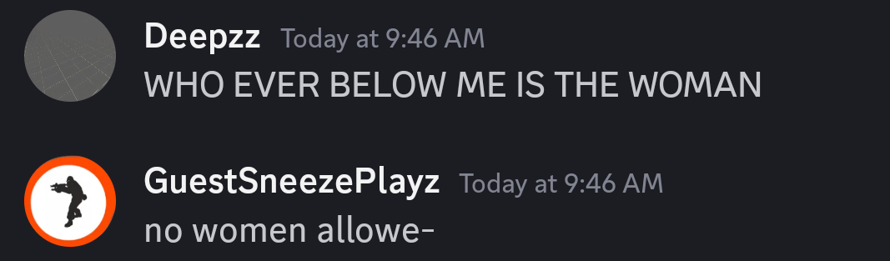
here’s him trying to slip away to be unnoticed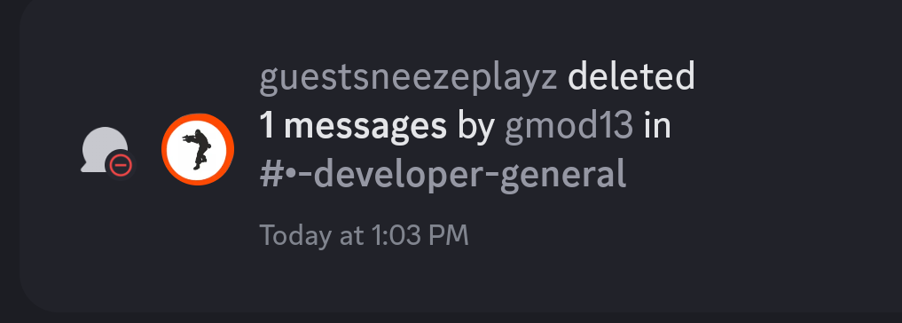

death threats
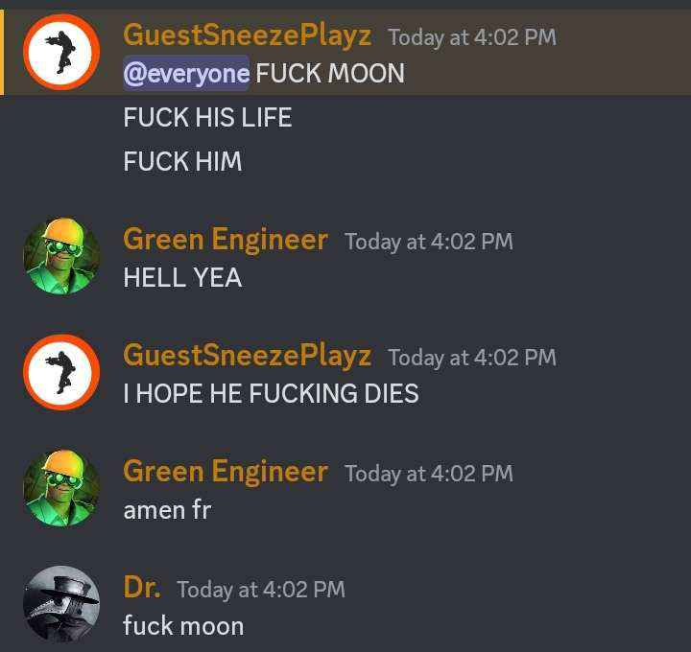
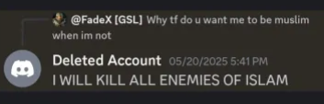
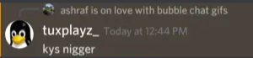
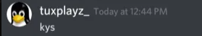
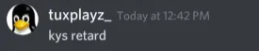
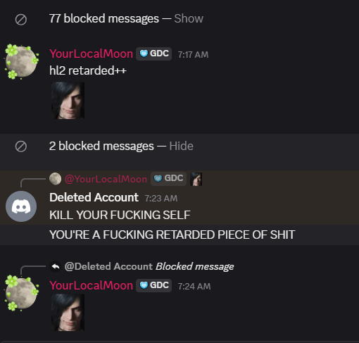

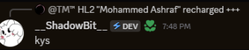
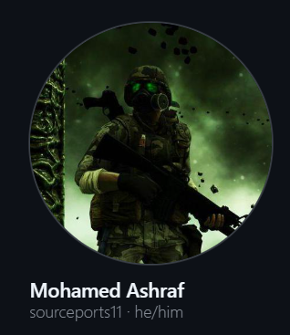
a bit of info on this screenshot above, if somehow guest is reading this, know that you literally put your real name in your github, so your autistic excuses like “WAHH WAHH THAT’S DOXING!!!” will not count

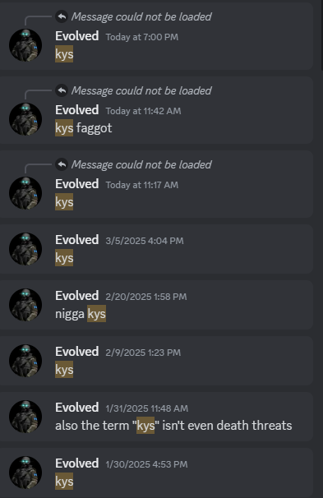
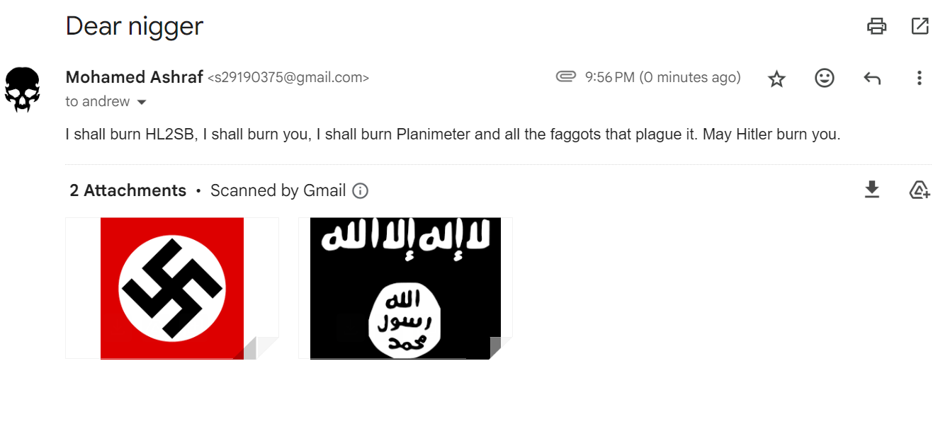
him supporting stealing
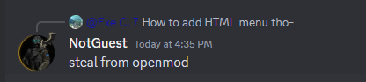
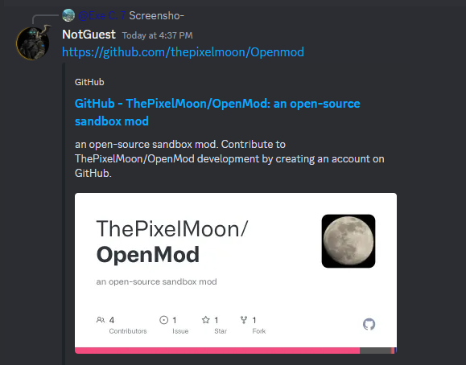
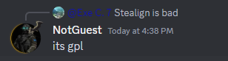
hating on other people’s hard work
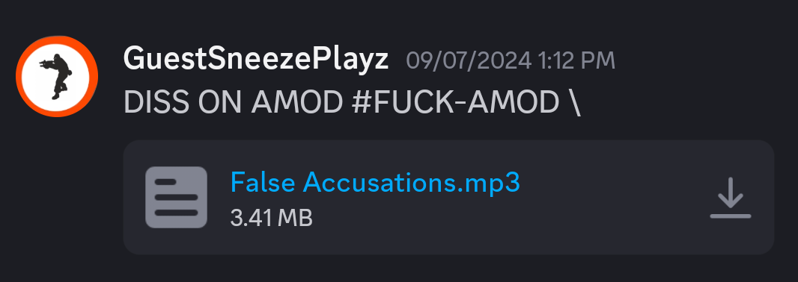
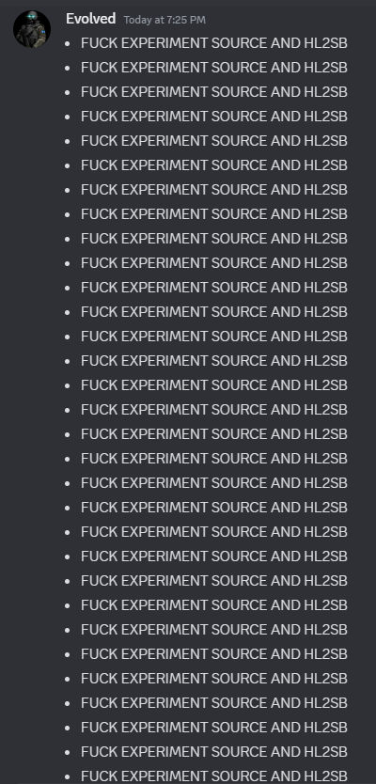
him begging for open source code so he could steal
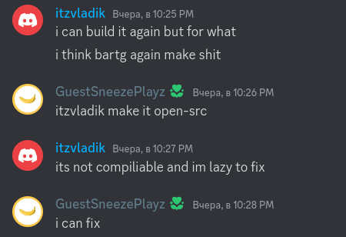
ps. he can’t fix, he’ll just take crap into his crappy made mods

some other screenshots
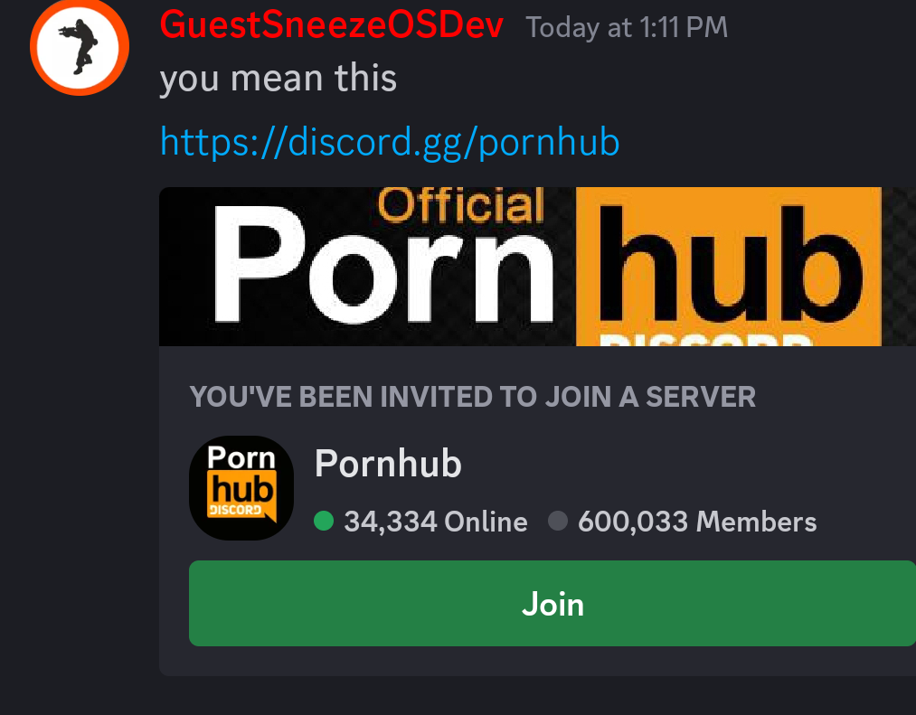
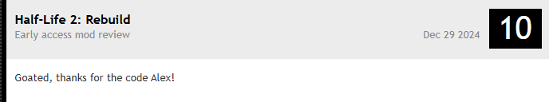
him mocking alter-source (basically calling his mod better, even tho it isn’t)
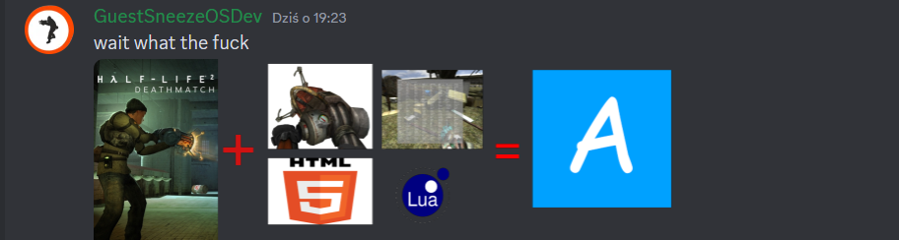
him being a crybaby
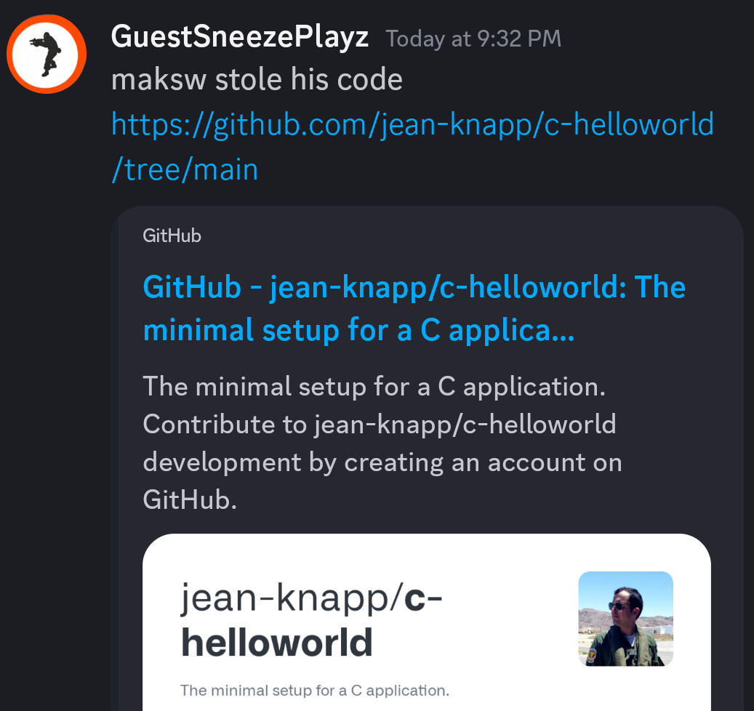
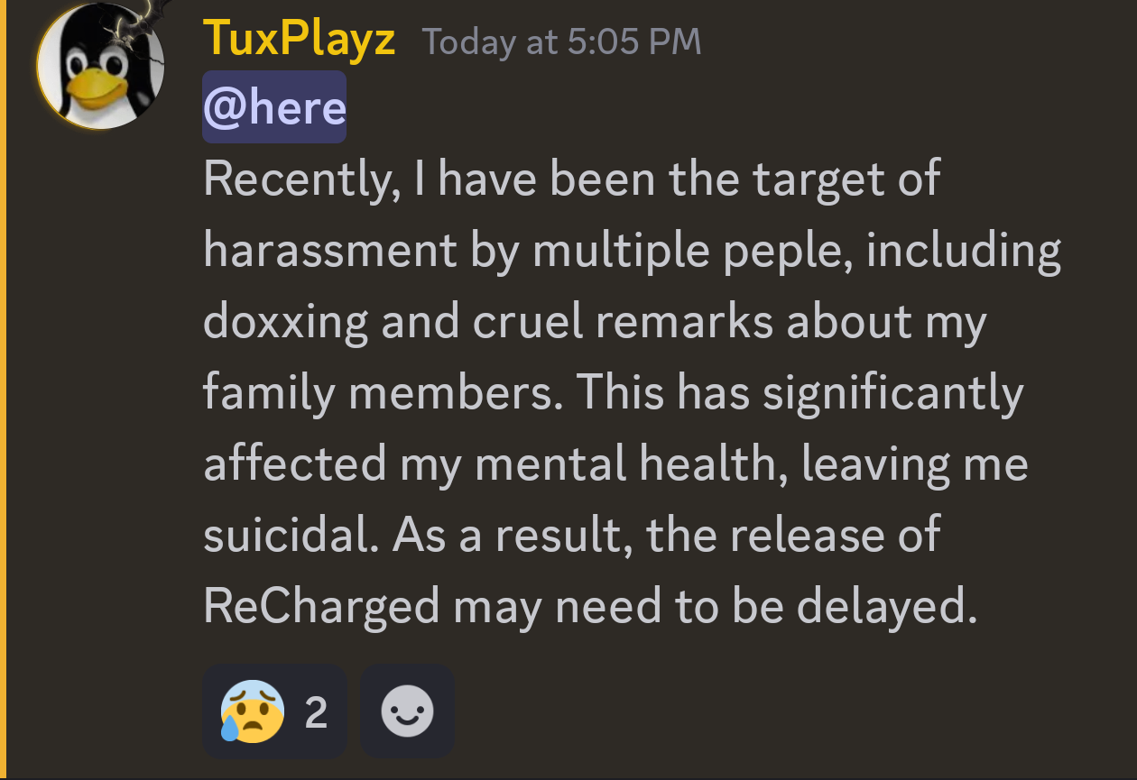
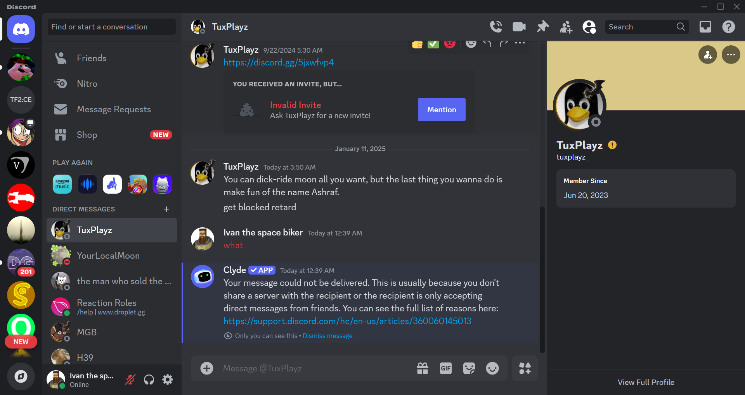
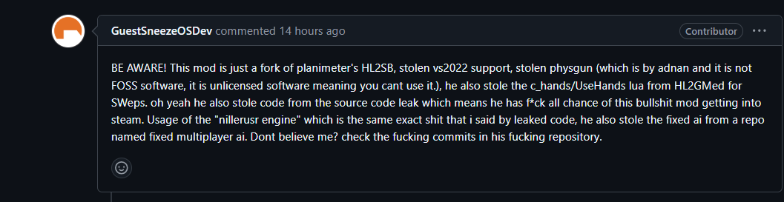
and all the videos he makes about me… (current count: 5 videos)
sexual content (CW)
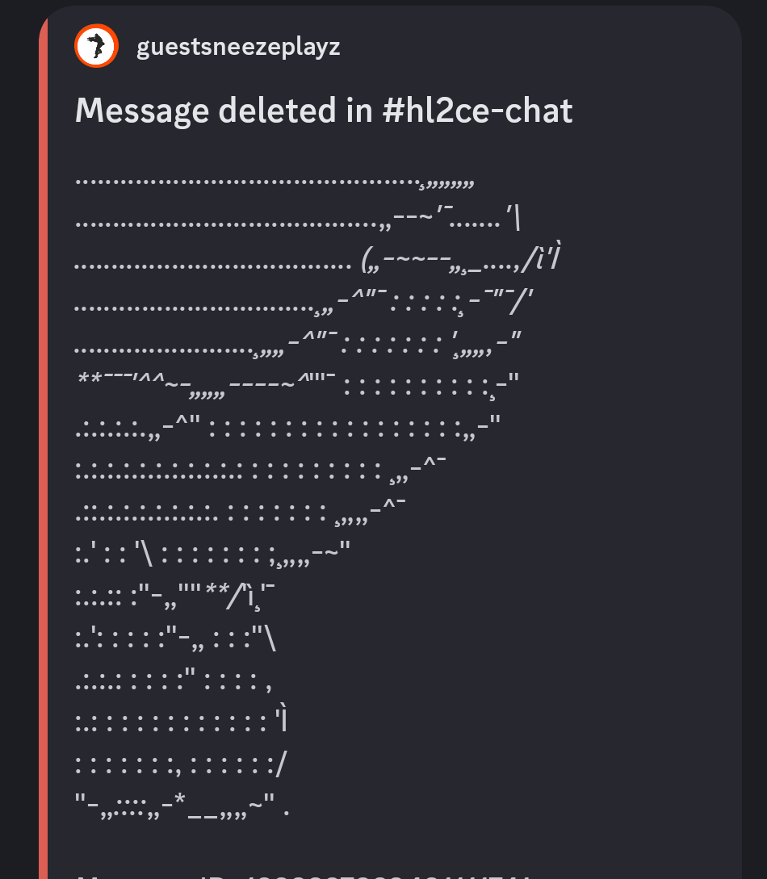
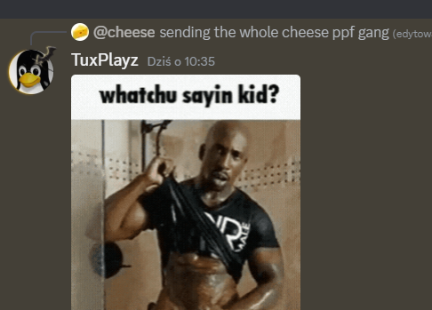
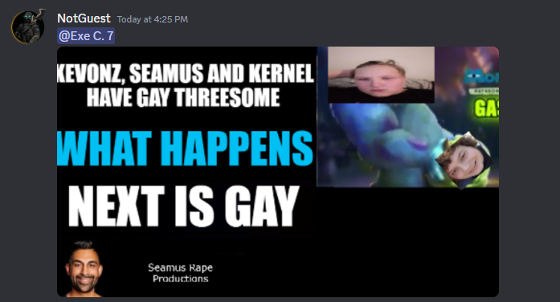
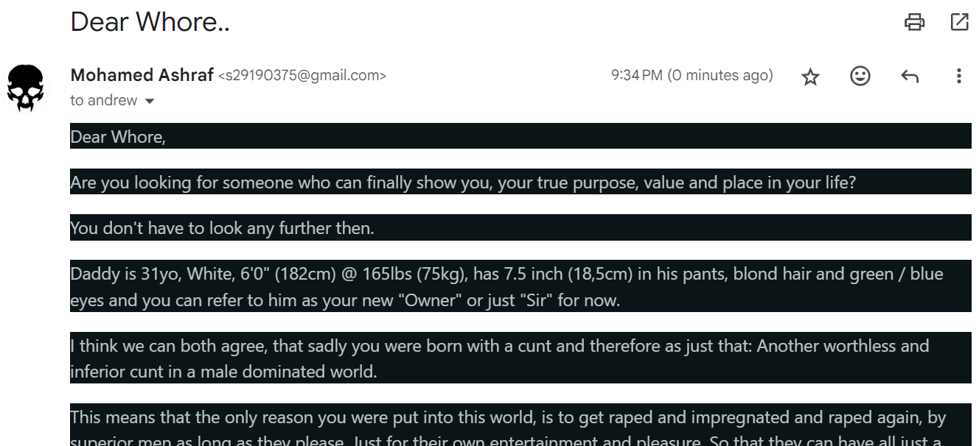
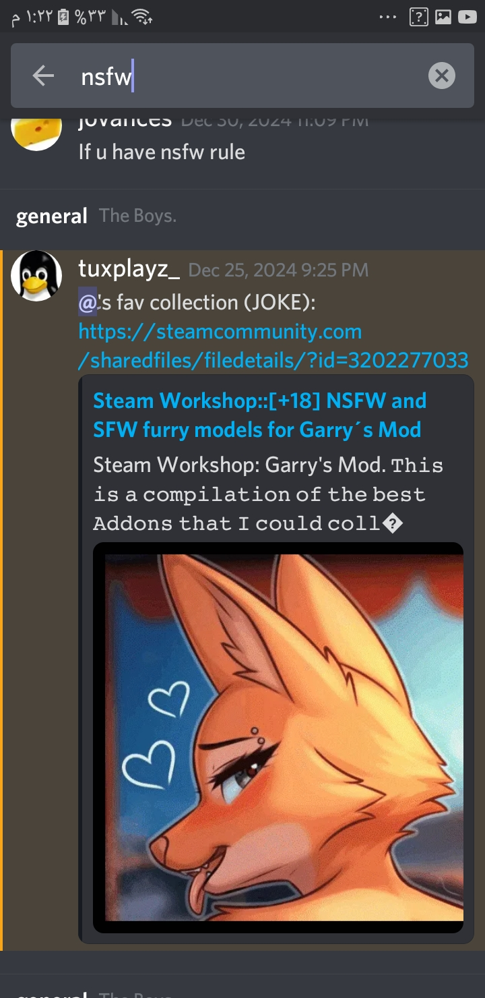

attention seeking
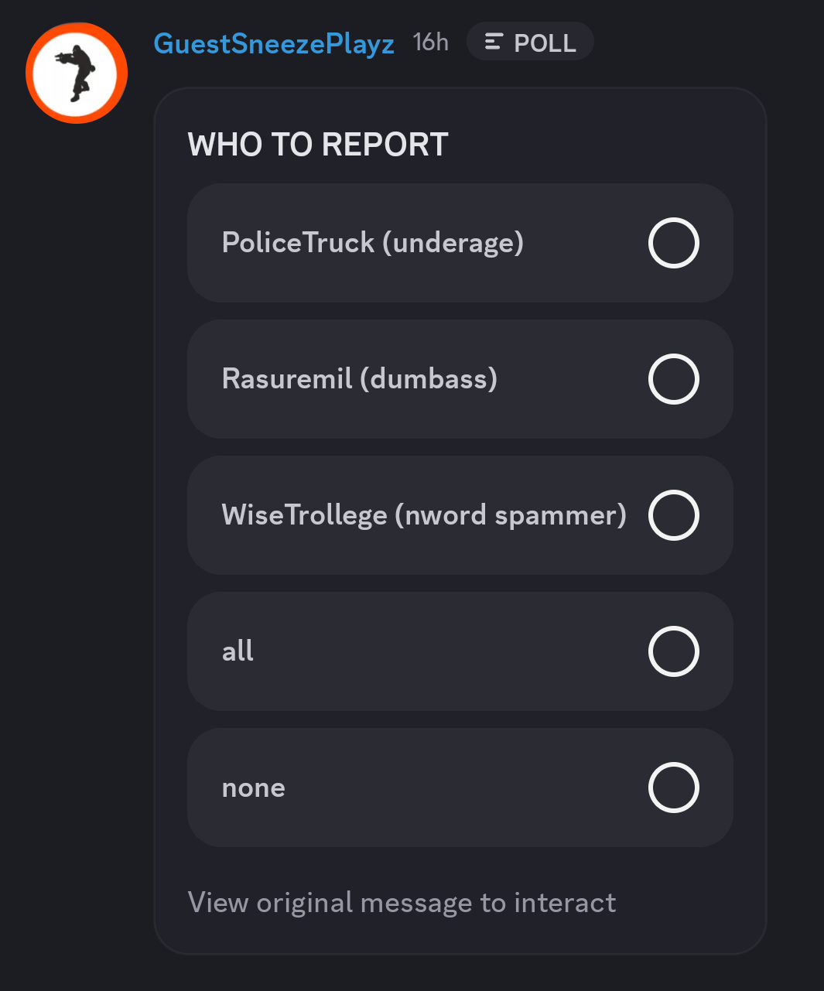
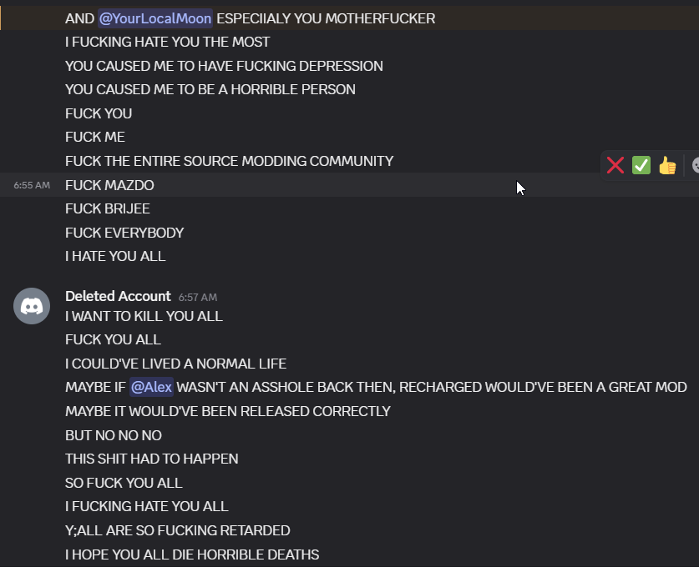
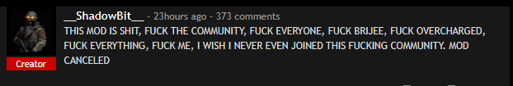
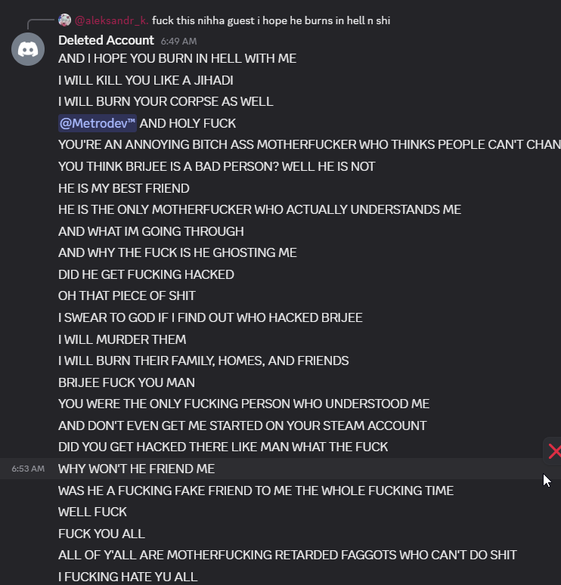
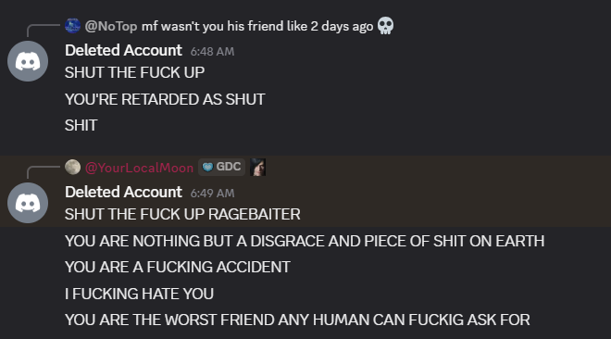
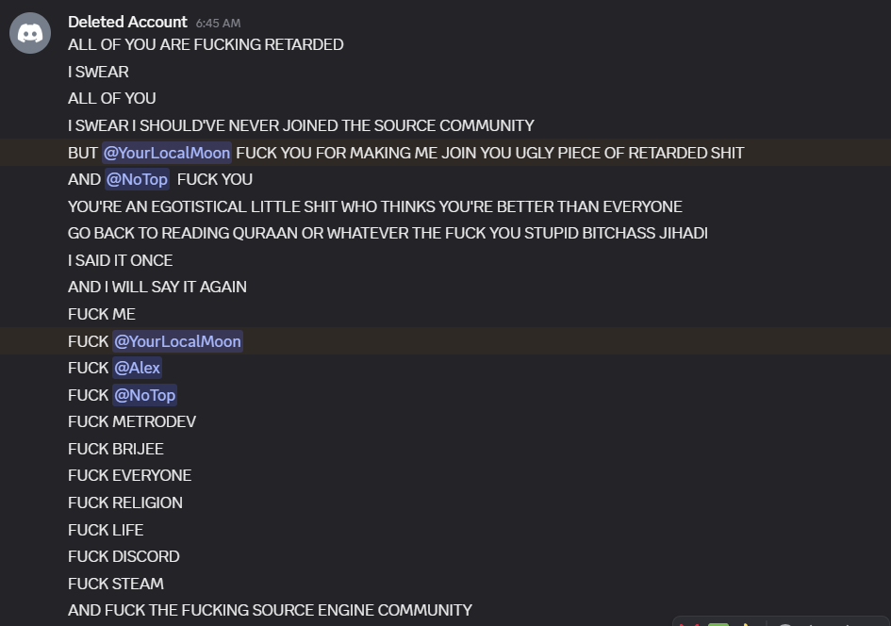
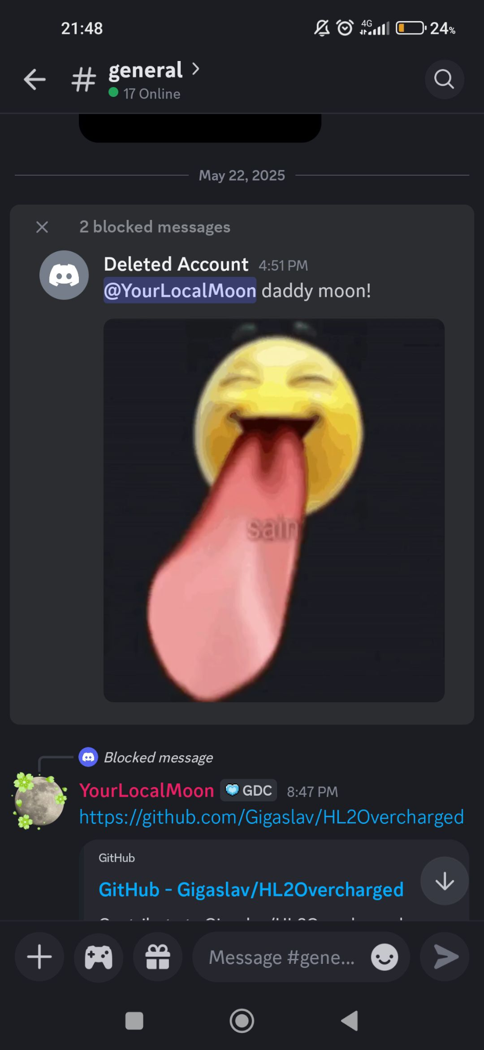
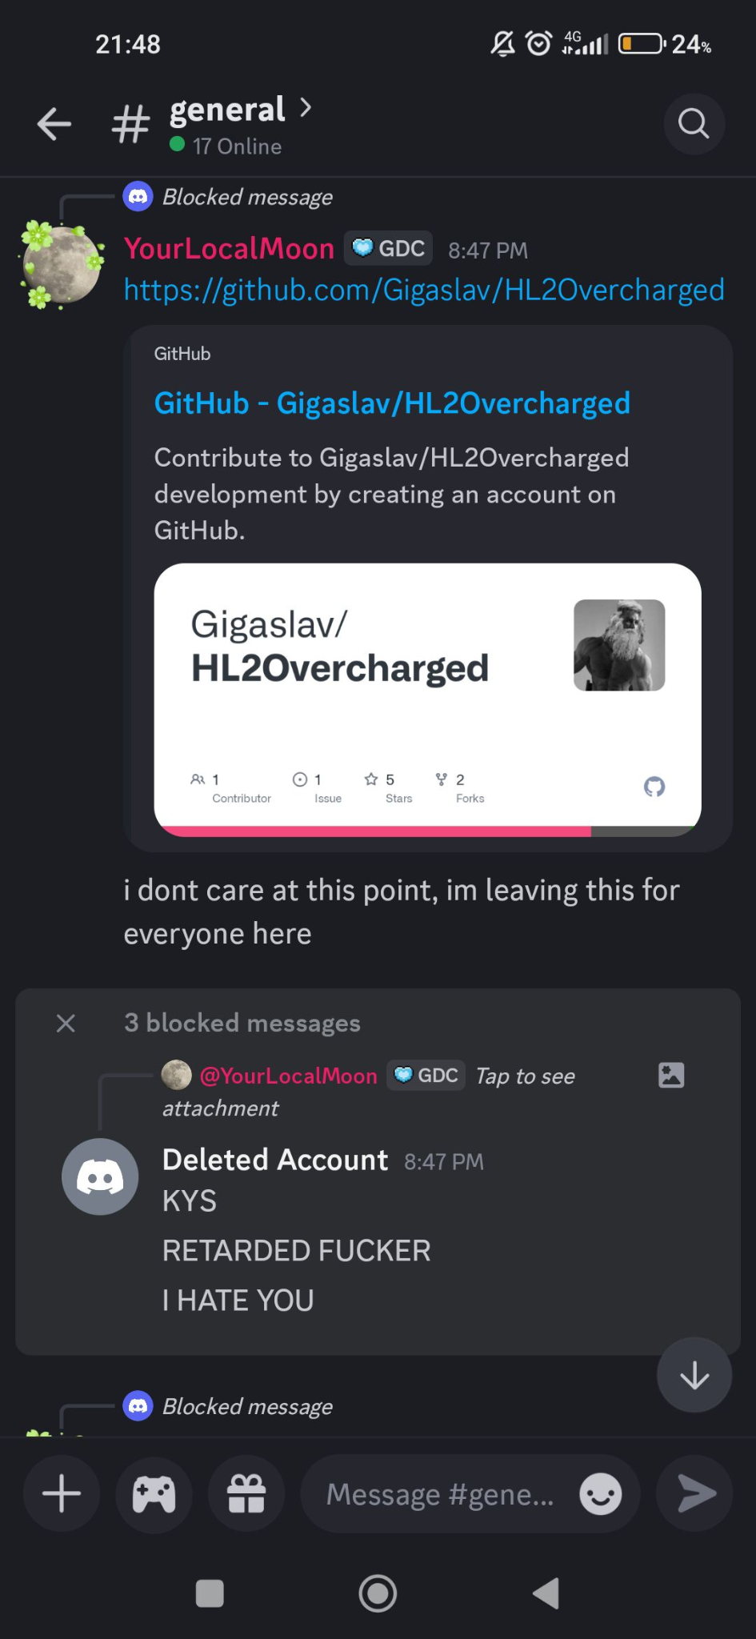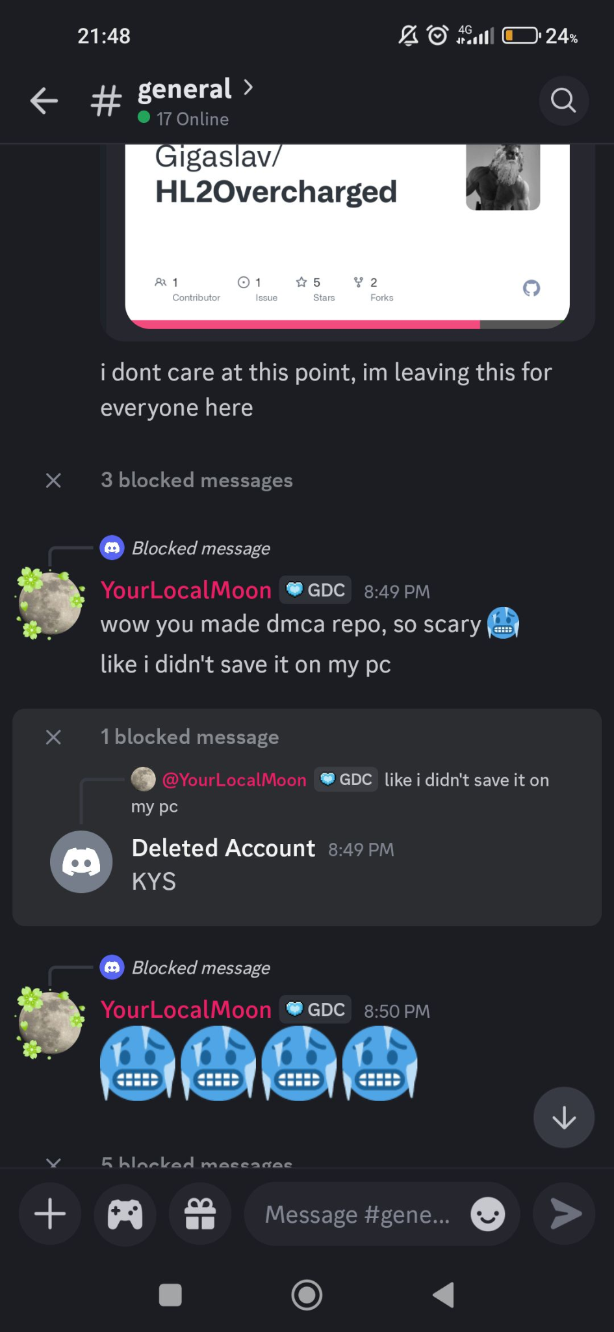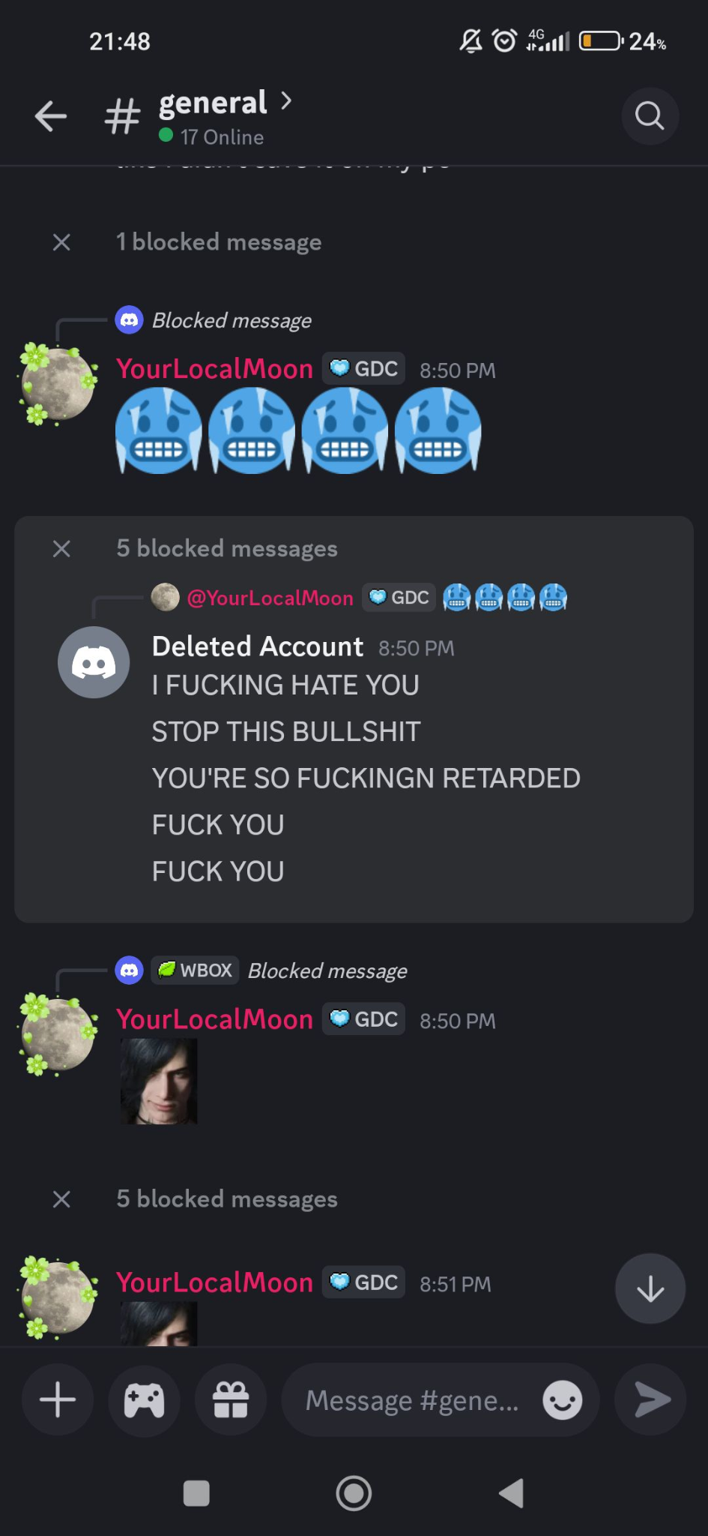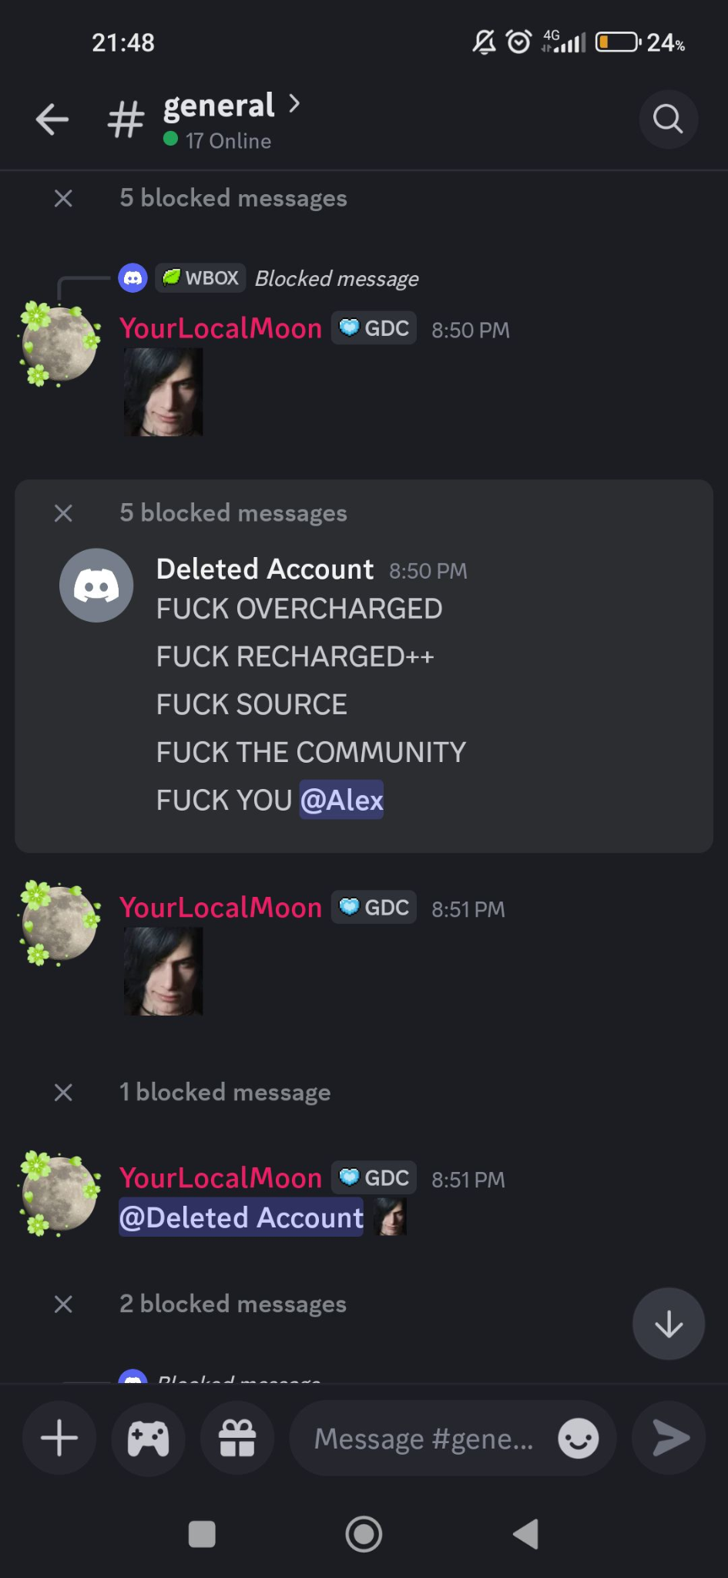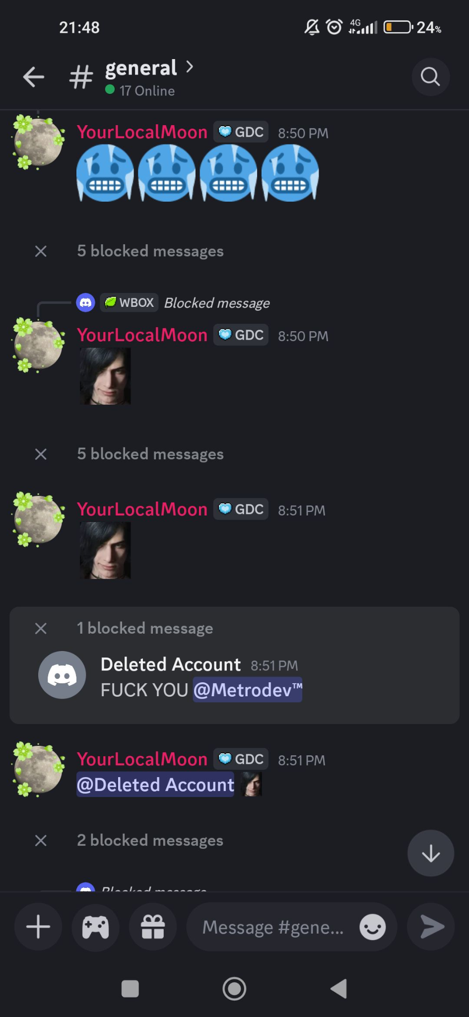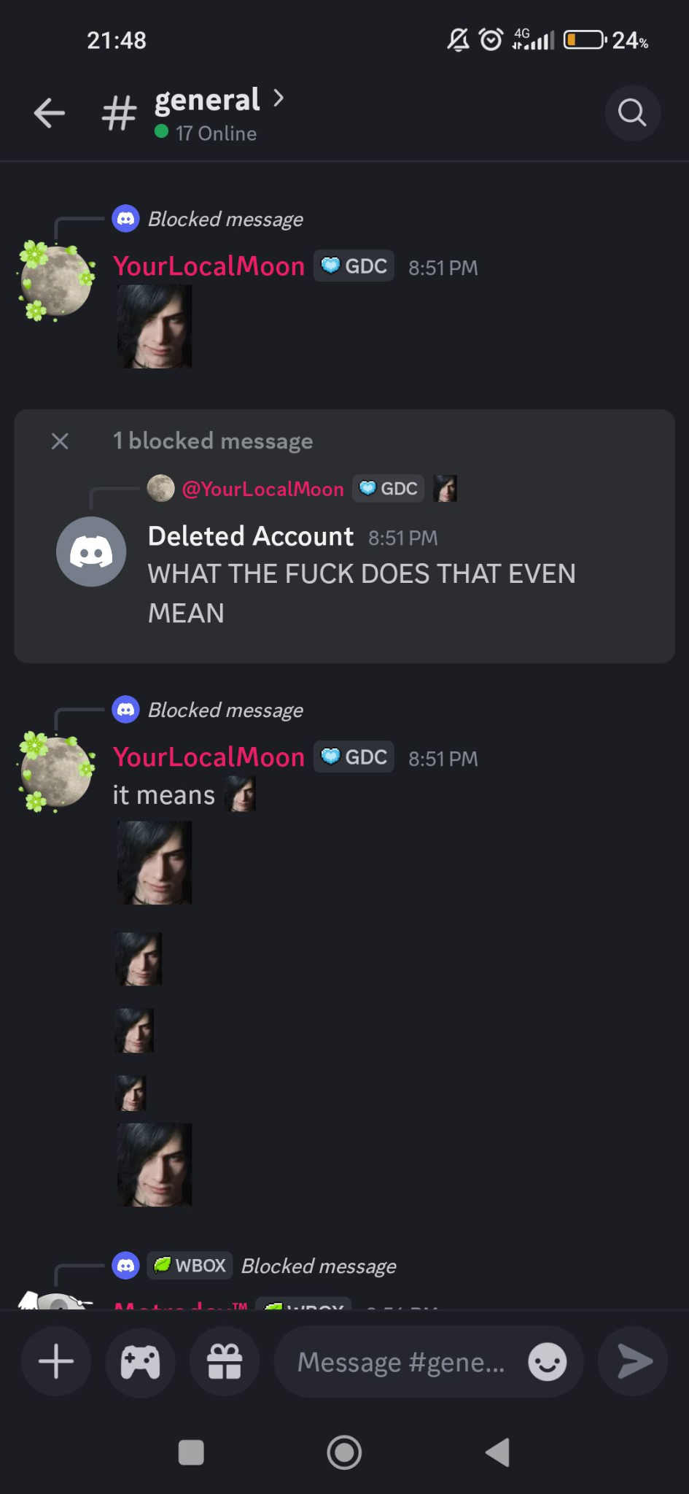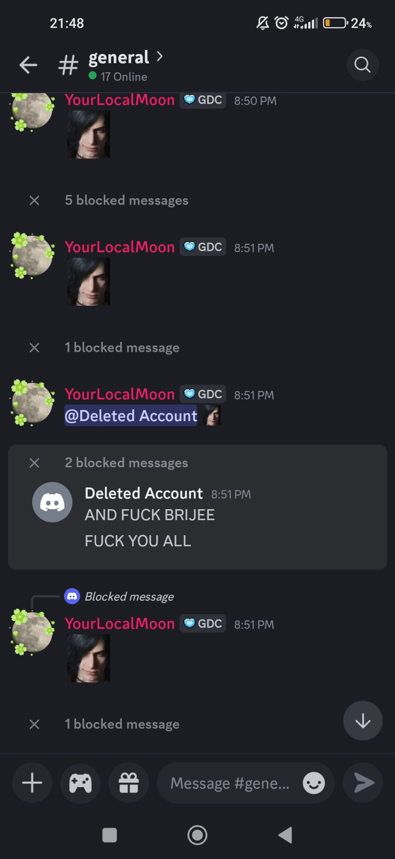
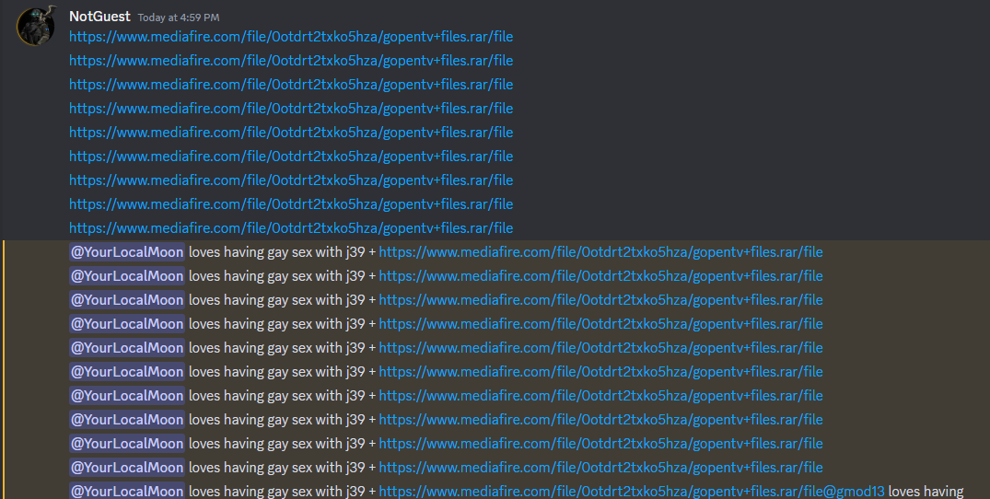
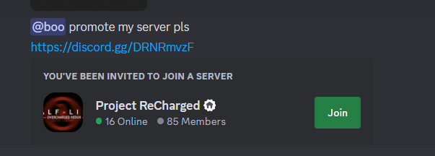
and also him making youtube videos of other people, they’re literally on his channel

him supporting raping
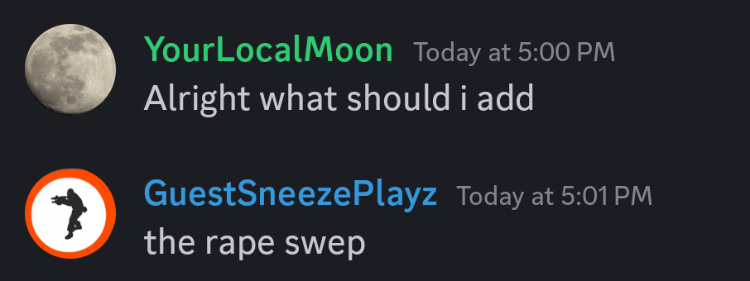
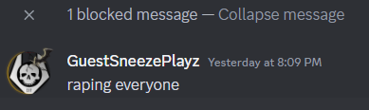
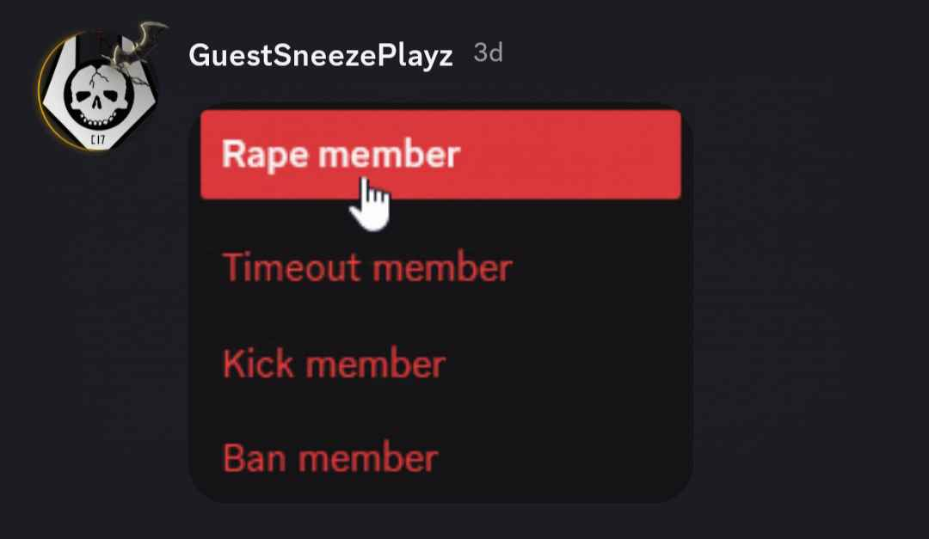

answering the other doc:
"a joke"
That did NOT sound like a joke.
You kept saying that everywhere.
And if you'll say that its dark humor, well too bad.
Because it's just you trying to slip away from the accusations.

MF HOW IS SANDBOX MODS - HARD WORK?
MF THOSE TWO ARE YOUR MODS

MF THOSE TWO ARE YOUR MODS
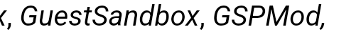

there's a difference between calling someone better than someone and calling someone better than everyone

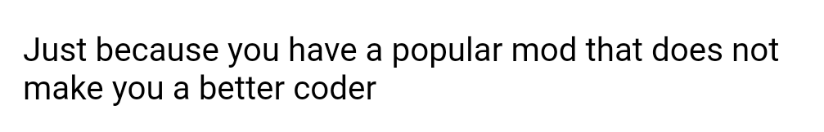
the only thing you do is steal assets and code, you literally did with guestsandbox
you can't add ANYTHING new

EXTRAS
guest trying to blame everything on someone else
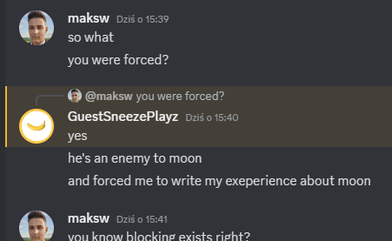
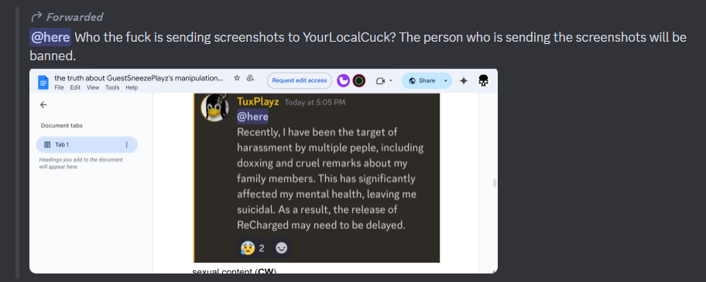
guest casually hating on people
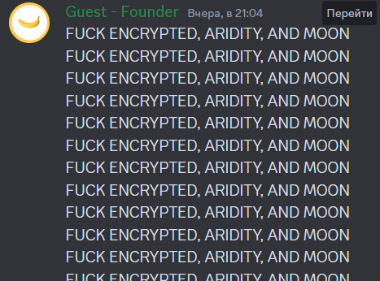
him supporting doxxers
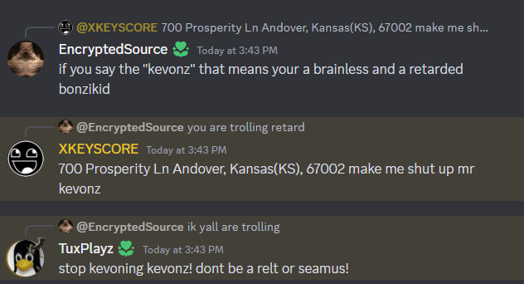
him being an idiot
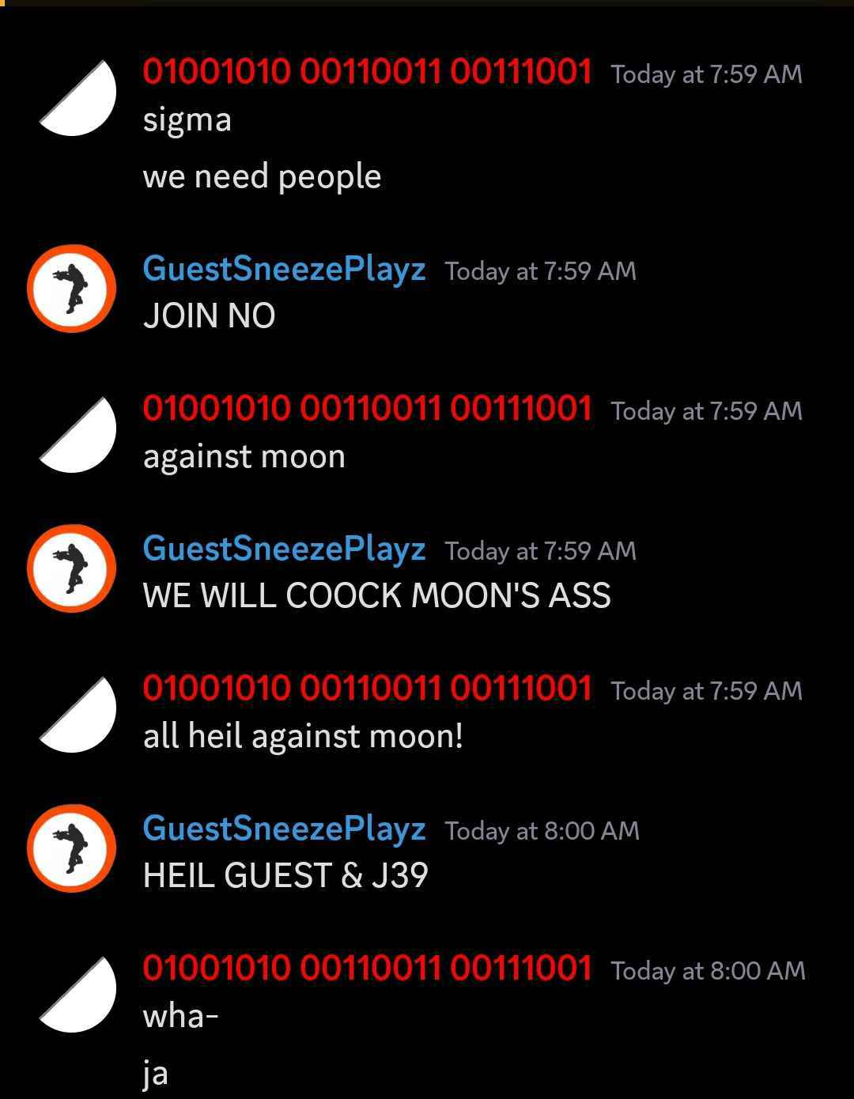

professional duncan’s opinion
